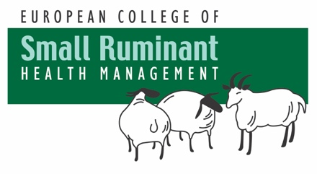
ECSRHM Diplomate Recertification
Application Form
2026

NAME
AFFILIATION
ADDRESS
EMAIL |  | TELEPHONE

Credentials Committee of the ECSRHM;
I, hereby, declare that I am currently in good professional standing and comply with Article 4 paragraph 4, of the ECSRHM Constitution 2024.
“Each Diplomate is required to spend at least 60 per cent of their professional time (i.e., at least 24 h per week) devoted to aspects of small ruminant health management such as but not limited to clinical practice, teaching, and research. Individuals who have not practiced at this level for two continuous years or the equivalent of two years during the previous five years, do not meet this requirement.”

Signature of Diplomate | Date

